Lab1 : Ubuntu using Virtual Box
- NAT VS BRIDGE
NAT mode:
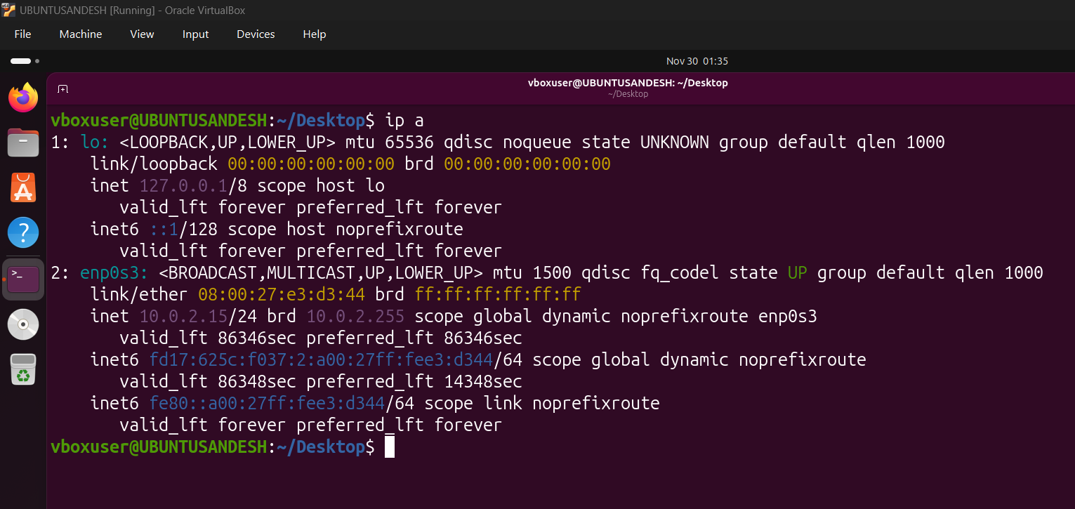
Bridge Mode:
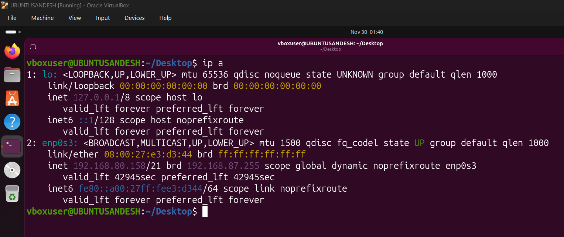

- Basic Commands:
cd
pwd
mkdir directory
touch file
ls
naano file (ctrl X, ctrl Y)
cat file
rm file
ls -ltr
rm directory (doesn’t allow)
rm -rf directory
df -h (shows storage)
free -mh (shows ram)
top (basic info..)

- Absolute Path vs Relative Path
- Use of Nginx:
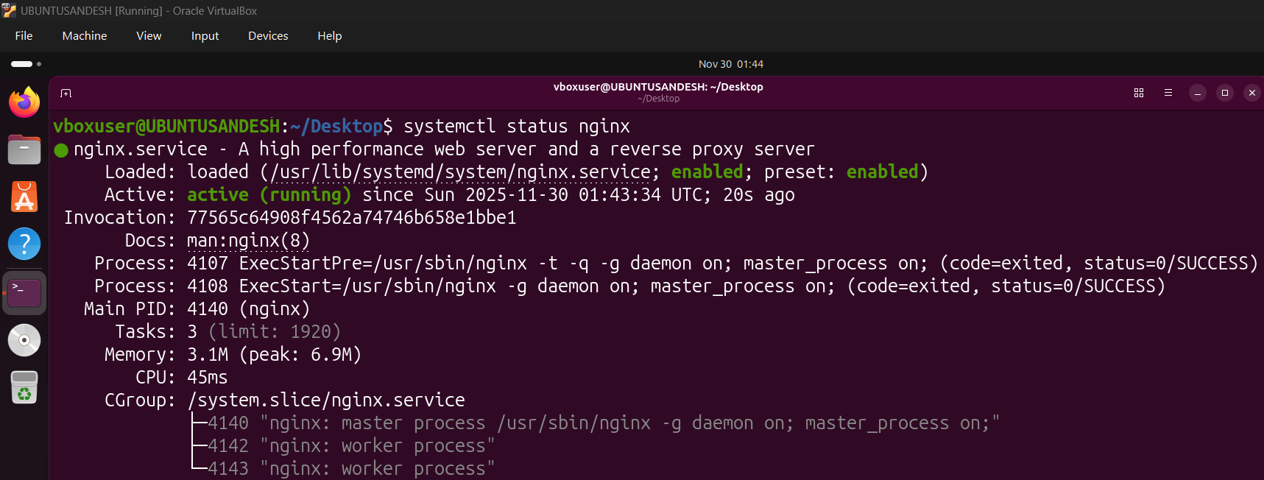
Check running nginx (ps -ef | grep nginx)
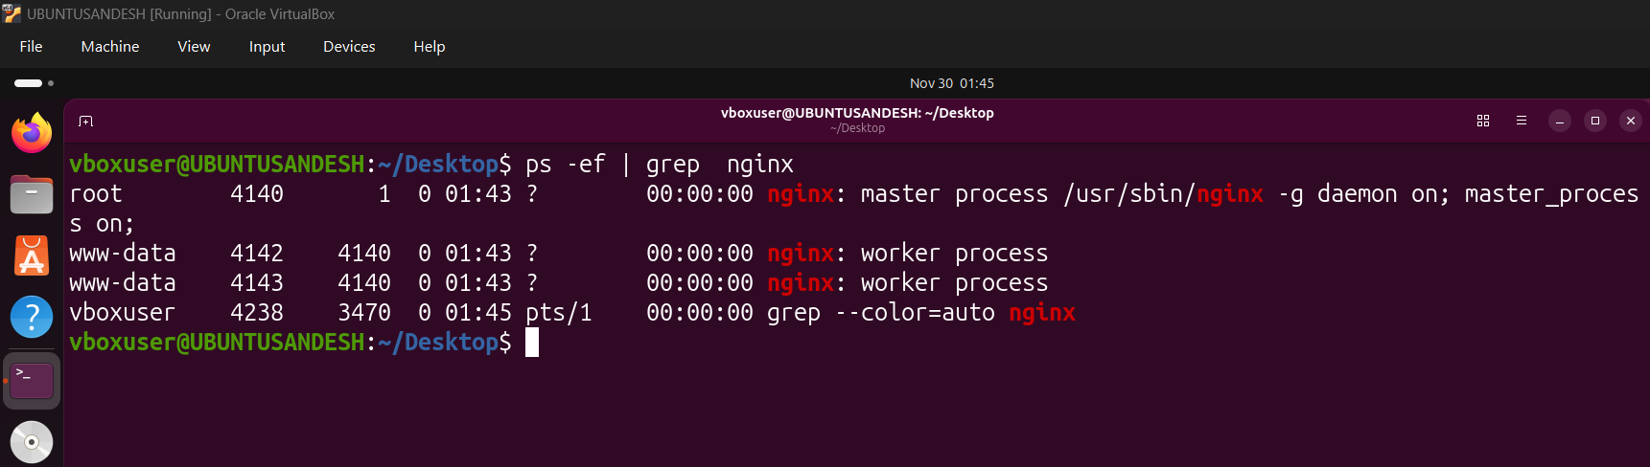
Install net-tools
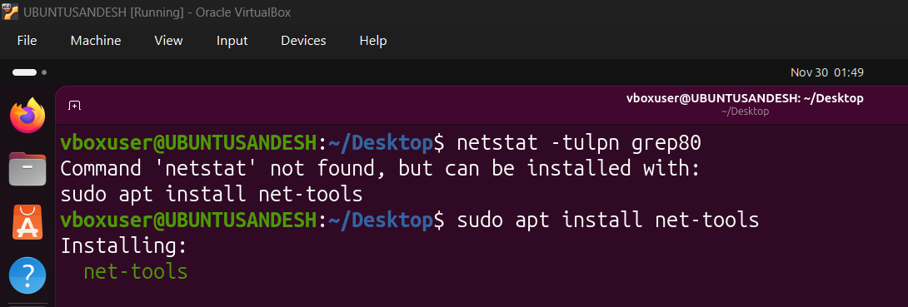
Netstat -tulpn | grep 80(22)
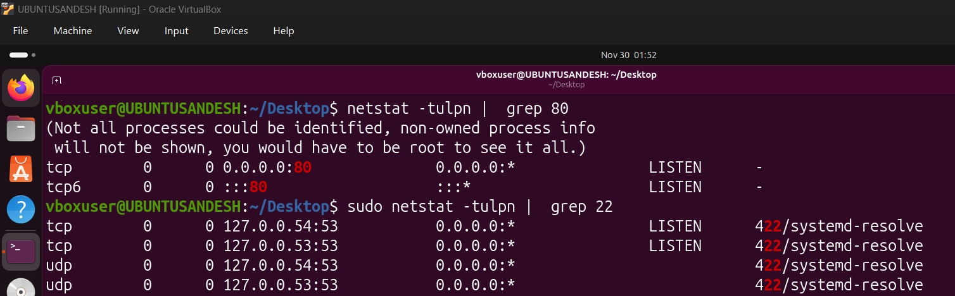

Overall Final summary and commands used:
